- KPI’S
- Total Revenue
select
round(sum(total_price), 2) AS Total_Revenue
from pizza_sales;

Output:
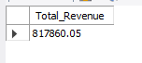
- Average order value
SELECT
ROUND(SUM(total_price)/count(distinct order_id), 2) AS Avg_order_value
FROM pizza_sales;

Output:
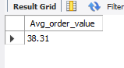
- Total pizza sold
SELECT
SUM(quantity) AS Total_Pizza_sold
FROM pizza_sales;

Output:
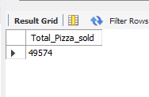
- Total Order Placed
select
count(distinct order_id) as Total_Order
from pizza_sales;

Output;
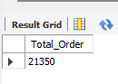
- Average pizza per order
select
sum(quantity) / count(distinct order_id) as Avg_pizza_per_order
from pizza_sales;

Output:
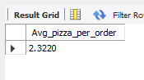
- DAILY TREND FOR TOTAL ORDER
SELECT
DAYNAME(order_date) AS day_name,
COUNT(DISTINCT order_id) AS order_count
FROM pizza_sales
GROUP BY DAYNAME(order_date);

Output:
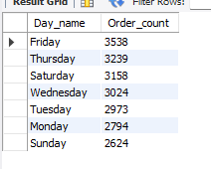
- Monthly Trend of Total Order
SELECT
MONTHNAME(order_date) AS Month_Name,
COUNT(DISTINCT order_id) AS Order_count
FROM pizza_sales
GROUP BY Month_Name;

Output:

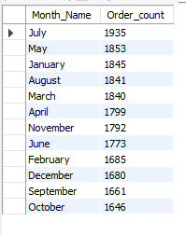
- Percentage of Sales by Pizza Category
SELECT
pizza_category,
ROUND(SUM(total_price), 2) AS Total_Sales,
CONCAT(
ROUND(
SUM(total_price) * 100 / (SELECT SUM(total_price) FROM pizza_sales),
2
),
'%'
) AS Pct_Total_Sales
FROM pizza_sales
GROUP BY pizza_category;

Output:
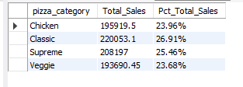
- Percentage of sales by Pizza Size
select
pizza_size,
round(sum(total_price), 2) as Total_Sales,
concat(
Round(
sum(total_price) * 100 / (select sum(total_price) from pizza_sales),
2
),
'%'
) as Pct_sales_by_pizza_size
from pizza_sales
group by pizza_size;

Output:
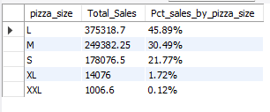
- Total Pizza Sold by Pizza Category
select
pizza_category,
sum(quantity) as Total_Pizza_Sold
from pizza_sales
group by pizza_category
order by Total_Pizza_Sold desc;

Output:
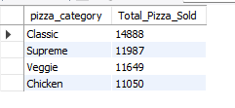
- Top 5 Pizzas by Revenue
select
pizza_name,
Round(
sum(total_price) , 2
) as Total_revenue
from pizza_sales
group by pizza_name
order by Total_revenue desc
limit 5 ;

Output:
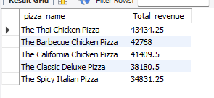

- Bottom 5 Pizzas By Revenue
select
pizza_name,
Round(
sum(total_price) , 2
) as Total_revenue
from pizza_sales
group by pizza_name
order by Total_revenue asc
limit 5 ;

Output:
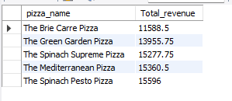

- Top 5 Pizzas by Quantity
select
pizza_name,
sum(quantity) as Total_Quantity
from pizza_sales
group by pizza_name
order by Total_Quantity desc
limit 5;

Output:
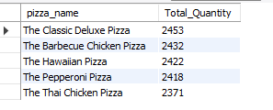

- Bottom 5 Pizzas by Quantity
select
pizza_name,
sum(quantity) as Total_Quantity
from pizza_sales
group by pizza_name
order by Total_Quantity asc
limit 5;
Output:
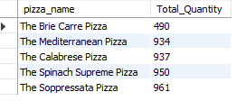

- Top 5 Pizzas by Total Order
select
pizza_name,
count(distinct order_id) as Total_order
from pizza_sales
group by pizza_name
order by Total_order desc
limit 5;

Output:
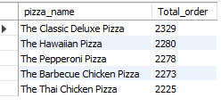

- Bottom 5 By Total Order
select
pizza_name,
count(distinct order_id) as Total_order
from pizza_sales
group by pizza_name
order by Total_order asc
limit 5;

Output:
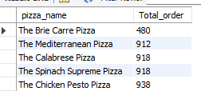

- CONCLUSION AND KEY BUSINESS INSIGHTS

The pizza sales analysis provides a clear overview of overall business performance and customer purchasing patterns. The business generated total revenue of $817,860.05 from 21,350 orders, with an average order value of $38.31 and an average of 2.32 pizzas per order. In total, 49,574 pizzas were sold.

The daily trend shows that Friday recorded the highest number of orders (3,538), while Sunday had the lowest (2,624). The monthly analysis shows July as the highest-order month (1,935) and October as the lowest (1,646), indicating variation in customer demand across days and months.
By pizza category, Classic pizzas contributed the largest share of sales at 26.91%, followed by Supreme (25.46%), Chicken (23.96%), and Veggie (23.68%). Large pizzas accounted for the highest share of sales by size at 45.89%, followed by Medium at 30.49%.

At the individual-product level, The Thai Chicken Pizza generated the highest revenue, while The Classic Deluxe Pizza had the highest quantity sold and the highest number of orders. The lowest-performing products by revenue, quantity, and order count were also identified, providing areas for further product-level analysis.

Overall, the analysis highlights the key revenue drivers, customer ordering patterns, popular pizza categories and sizes, and high- and low-performing products. These insights can be used to support decisions related to inventory planning, promotional campaigns, product positioning, and sales strategy.

